SQL Assignment 1-SivaPriyaPalakurthi

url to check the code: https://codehs.com/sandbox/id/sql-XF6iBT

Create Table Customers

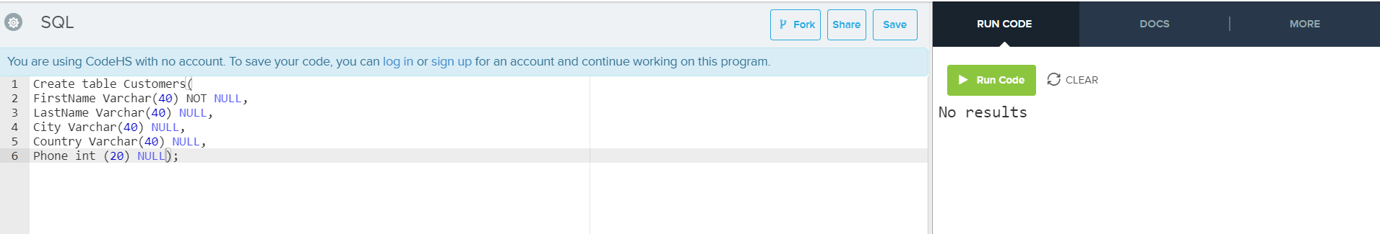

Creating Orders Table

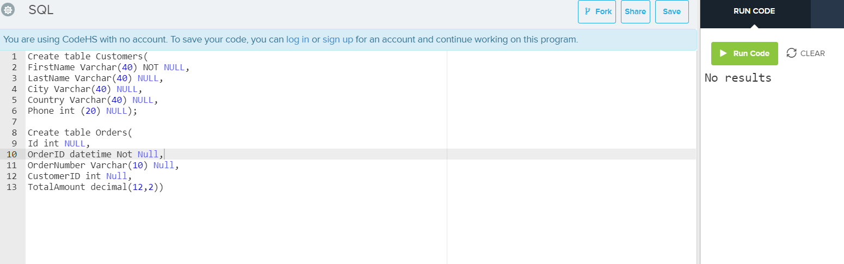

Inserting Values into Customers and Displaying Values from Customers table.

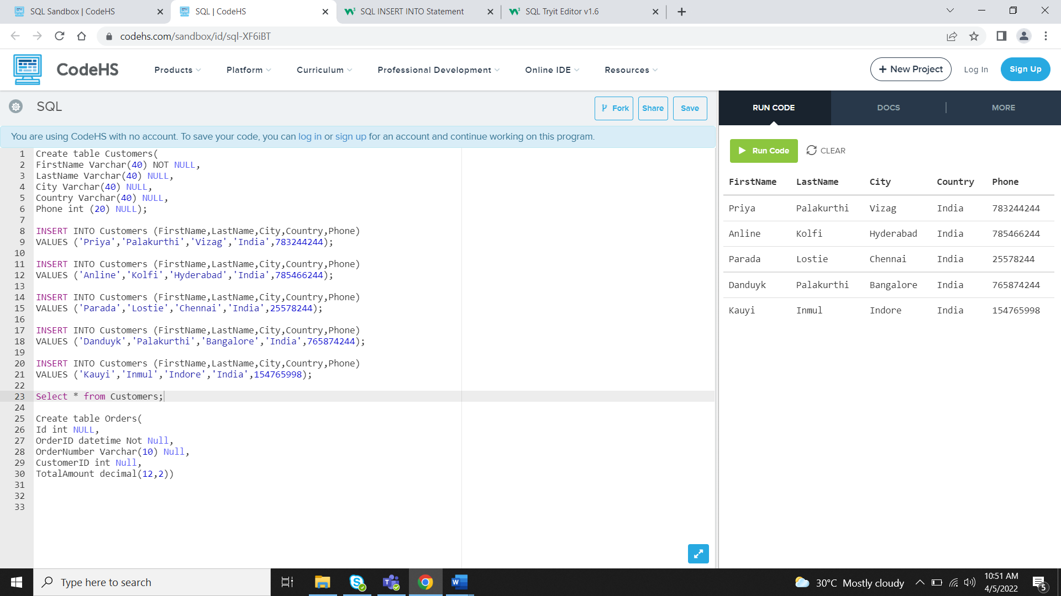

Inserting values in to Orders table and displaying values from Orders table

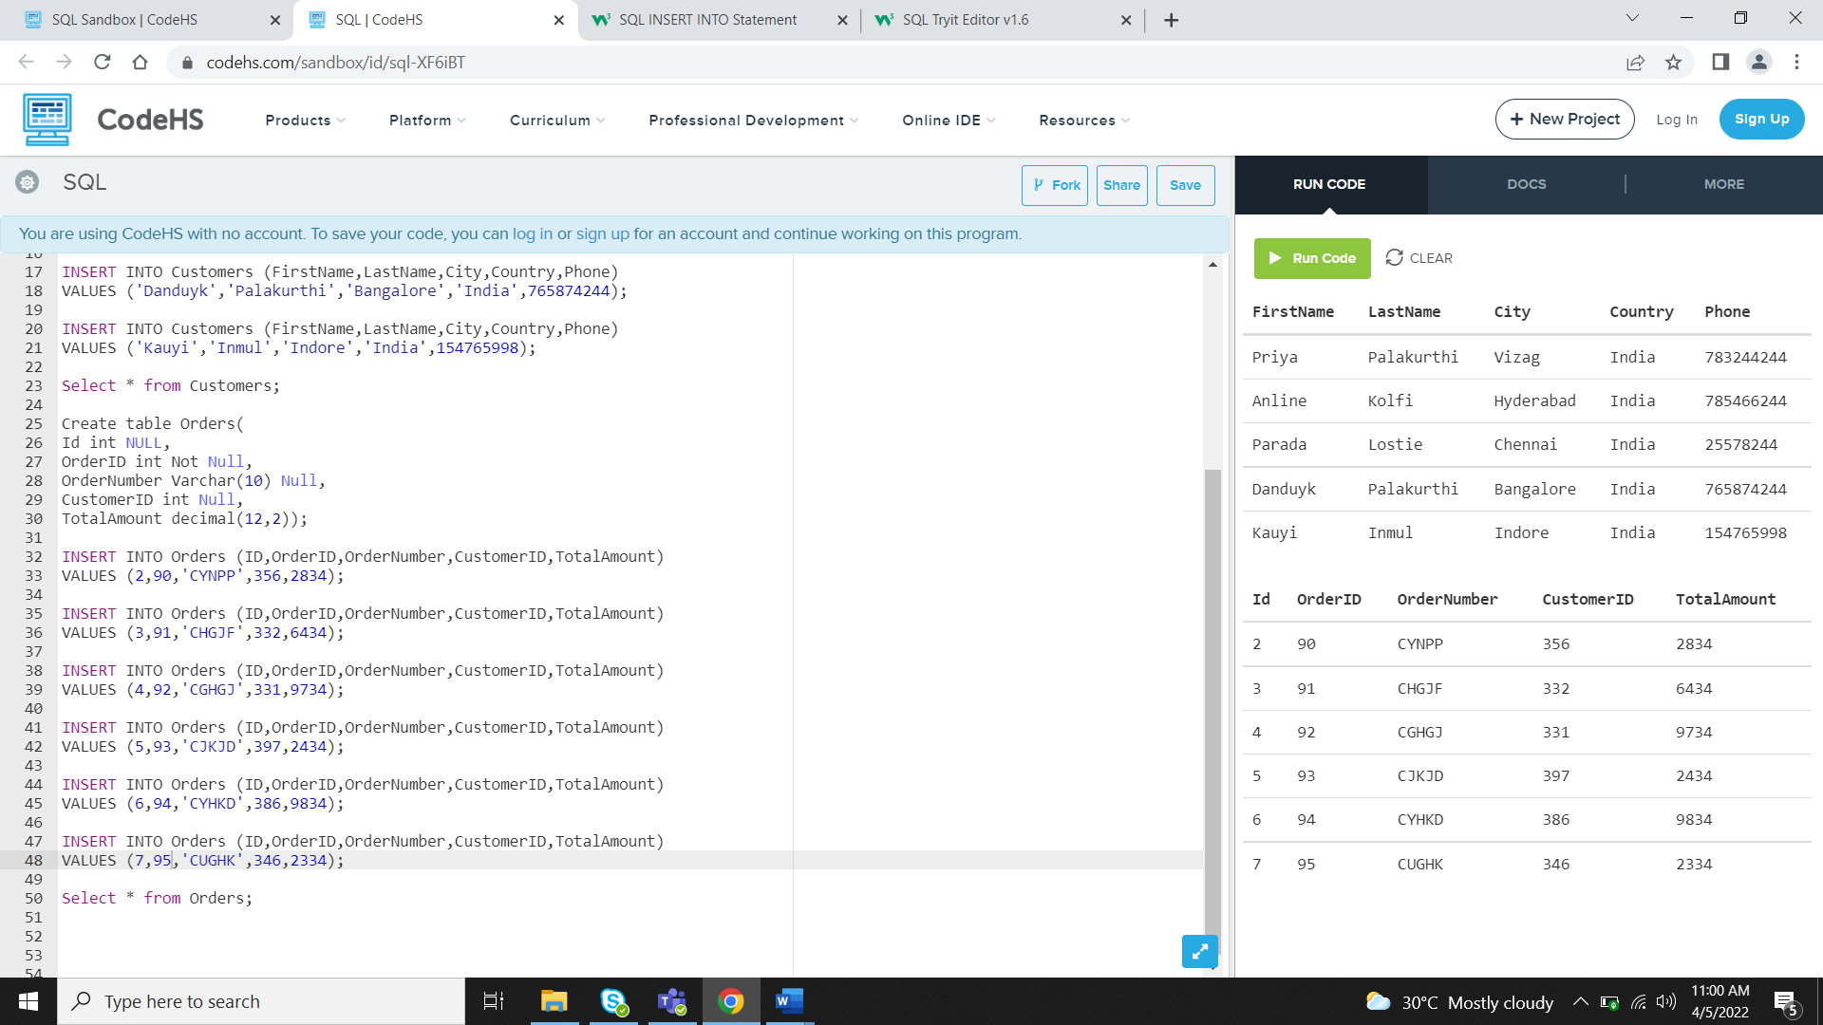

6.write a query to display Country whose name starts with A or I

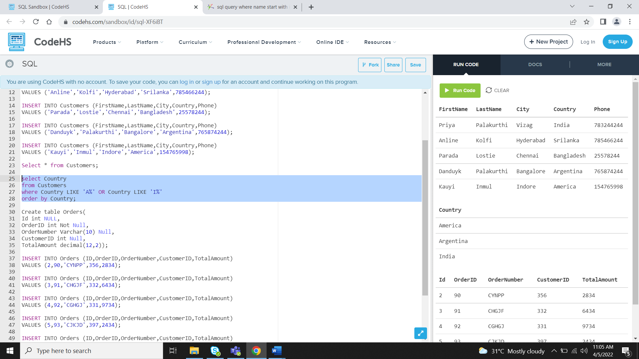

write a query to display whose name of customer whose third character is i

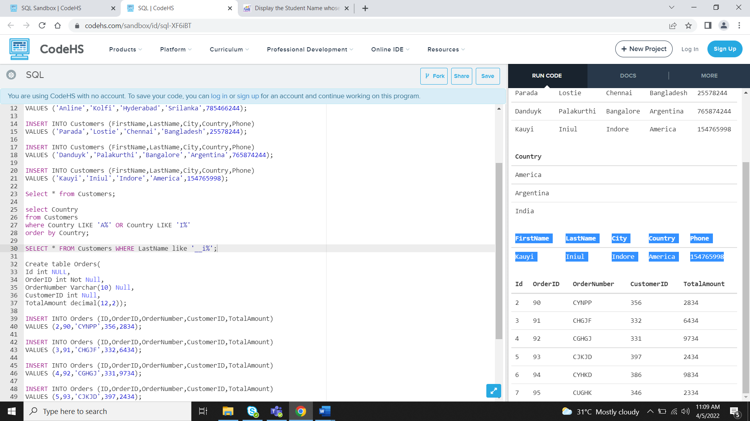

1.Desgin the above database with following table by applying Primary key and Foreign key

**Scenatio2:** Taking Id as Primary key and CustomerID ad Foreign Key

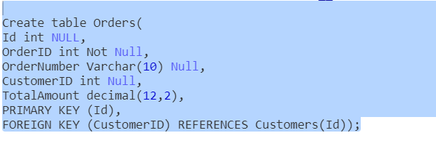

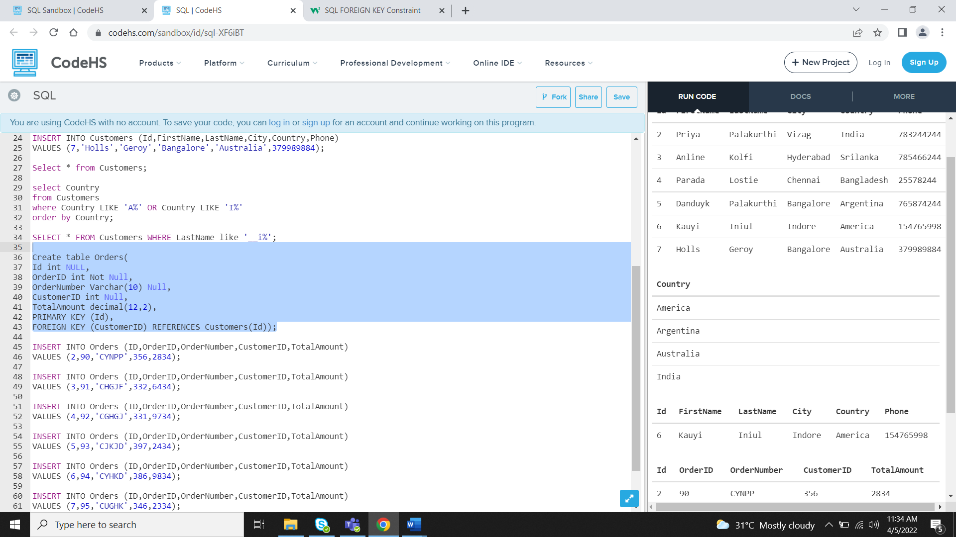

SQL Assignment2- SivaPriyaPalakurthi

1. Display the details from Customer table who is from country Germany

Select * from Customer where Country = 'Germany'

Employee Table

CREATE TABLE Employee(

EmployeeId int IDENTITY(1,1) PRIMARY KEY,

FirstName nvarchar(40),

LastName nvarchar(40),

City nvarchar(40),

Country nvarchar(40),

Phone nvarchar(40),);

INSERT INTO dbo.Employee(FirstName,LastName,City,Country,Phone)

VALUES ('Max','Smith','New York','USA','148523697'),

('Amit','Sexana','Bangalore','INDIA','741258963'),

('Shobhit','Dubey','Mumbai','India','741258931'),

('Sita','Gupta','Canada','UK','3698521470'),

('Chanchal','Singh','London','UK','789541230');

2. Display the full name of the employee

SELECT * FROM Employee;

Display the customer details who has Fax number

ALTER TABLE Customer

ADD FaxNumber nvarchar(12);

SELECT * from Customer Where FaxNumber is not Null;

display the customer details whose name holds second letter as U

Select * from Customer Where FirstName Like '_u%';

select order Details where unit price is greater than 10 and less than 20

Select * From OrderItem Where UnitPrice >10 and UnitPrice <20;

# Alternative

Select * From OrderItem Where UnitPrice between 10 and 20;

Display order details which contains shipping date and arrange the order by date

SELECT OrderDate AS SHIPPING_DATE

FROM OrderTable

ORDER BY OrderDate ASC;

Print the orders shipped by ship name 'La corned'abondance' between 2 dates(Choose dates of your choice)

SELECT ShipName

FROM OrderTable

where ShipName =''La corned abondance' AND'OrderDate BETWEEN '2022-04-02' AND '2022-04-05'

ORDER BY OrderDate ASC;

Print the products supplied by 'Exotic Liquids'

SELECT * FROM ProductTable

WHERE Package ='EXOTIC LIQUIDS';

print the average quantity ordered for every product

select avg(quantity) From OrderItem INNER JOIN Product ON OrderItem.ProductId = Product.id;

Print all the Shipping company name and the ship names if they are operational

SELECT ShipCompany, ShipName

From ShippingTable

Where Operational = 'yes';

Print all Employees with Manager Name

SELECT E.NAME AS EMPLOYEE_NAME,M.NAME AS MANAGER_NAME

FROM Employee E JOIN Employee M

ON E.MANAGER=M.MANAGER;

-----------------------------------------

Print the bill for a given order id .bill should contain Productname, Categoryname,price after discount

SELECT OI.OrderId,P.ProductName,P.Category,P.Discount

FROM ProductTable P INNER JOIN OrderItemTable OI

ON P.ProductId=OI.ProductId;

Print the Total price of orders which have the products supplied by 'Exotic Liquids' if the price is > 50 and also print it by Shipping company's Name

SELECT SUM(UnitPrice) As Total,CompanyName

FROM ProductTable

GROUP BY ProductSupplied

having ProductSupplied ='exotic liquids' and UnitPrice >50;

SQL Assignment3- SivaPriyaPalakurthi

**1.write a query to display the orders placed by customer with phone number 689798045**

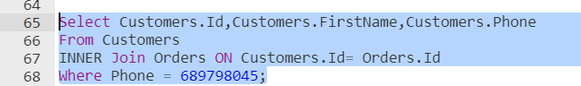

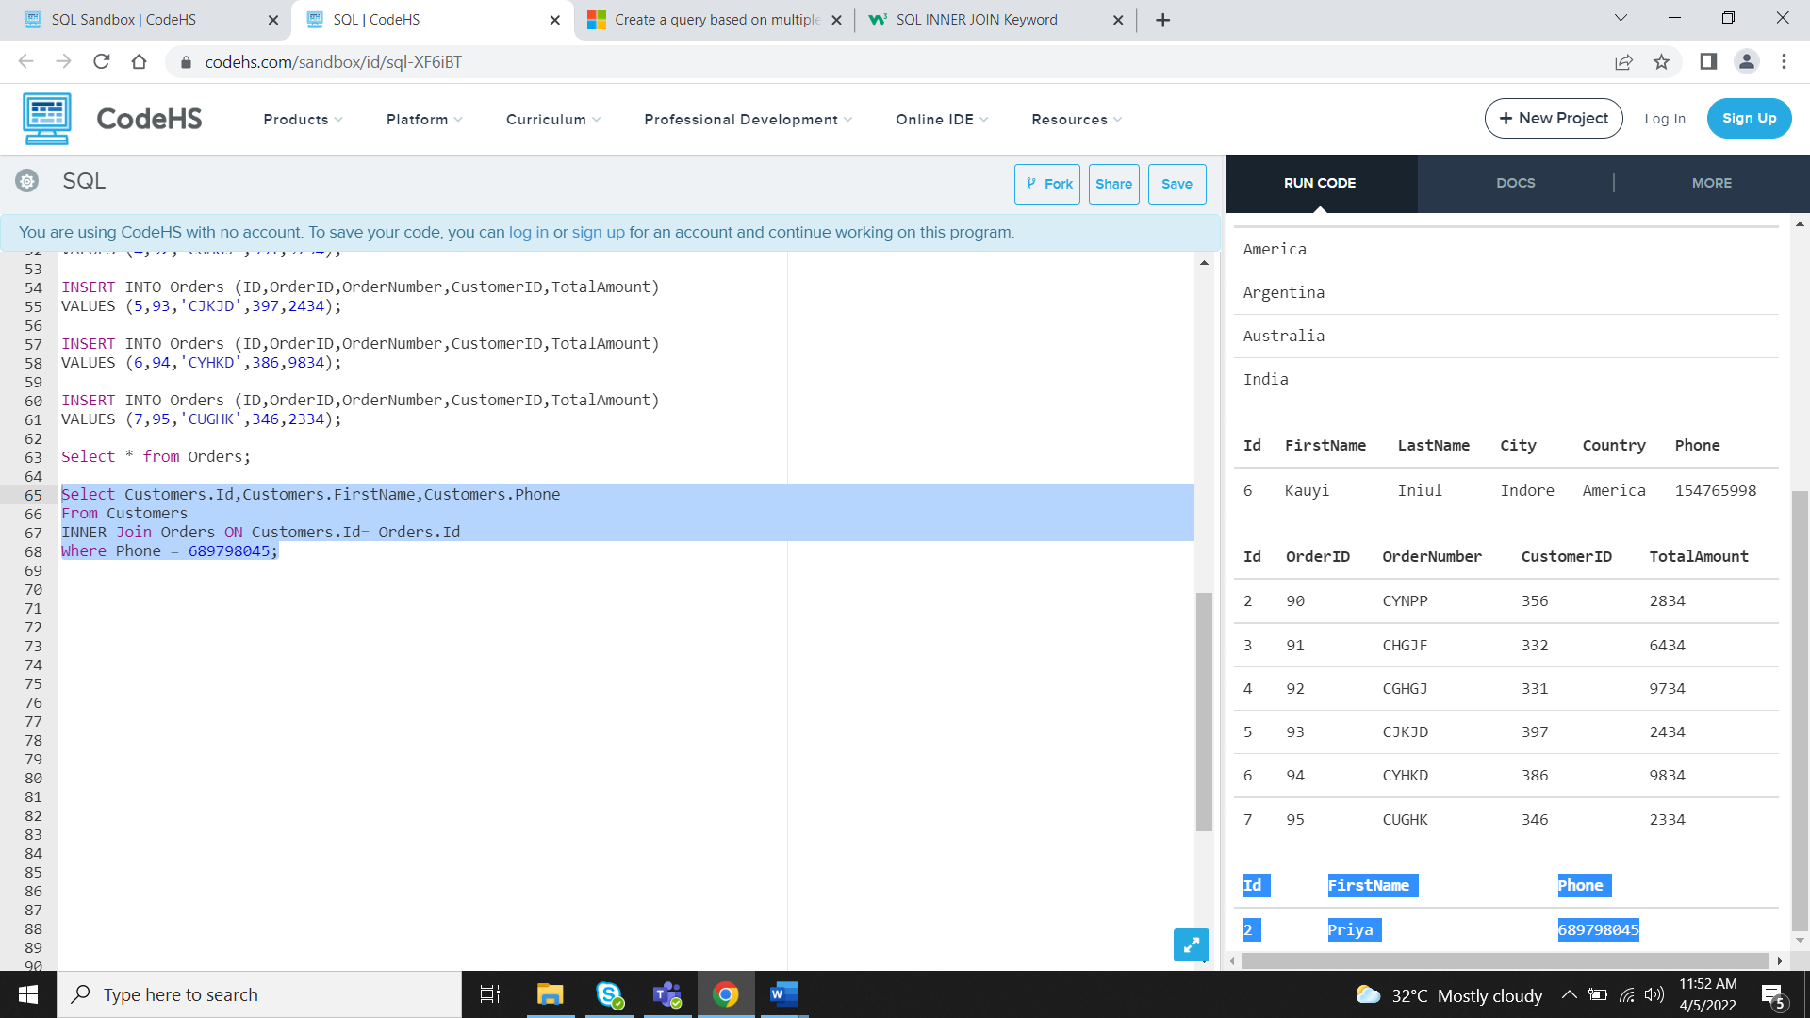

**2.  fetching all the products which are available under Category ‘Seafood’.**

Create a Product table

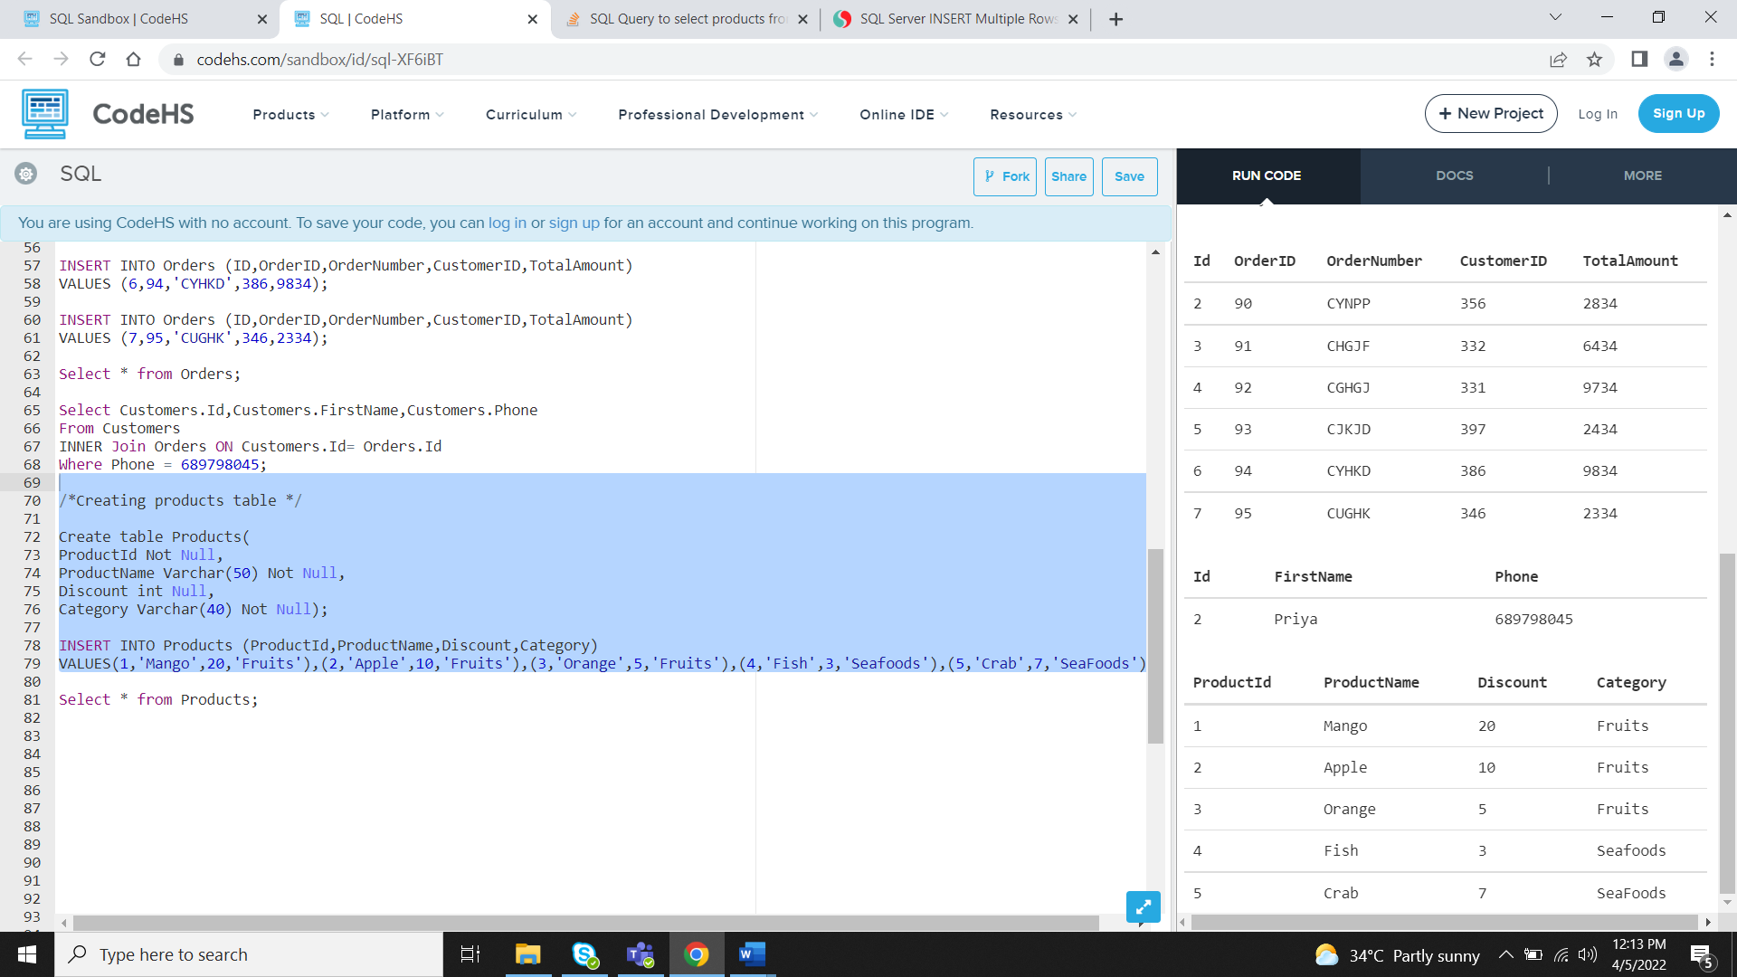

**Query:**



**Result**

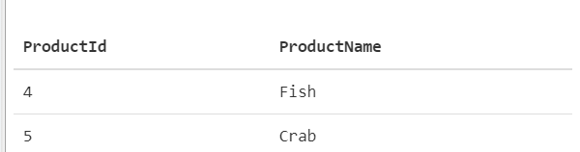

**3.Display the orders placed by customers not in London**

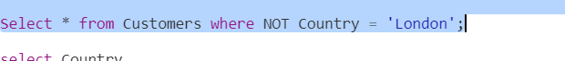

**Result:**

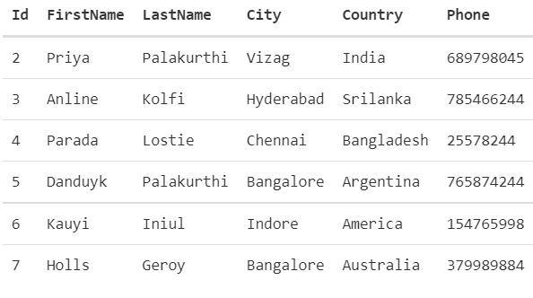

**4. selects all the order which are placed for the product Chai.**

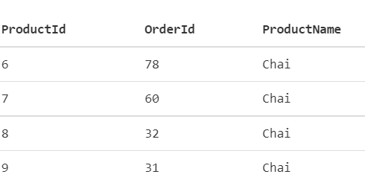

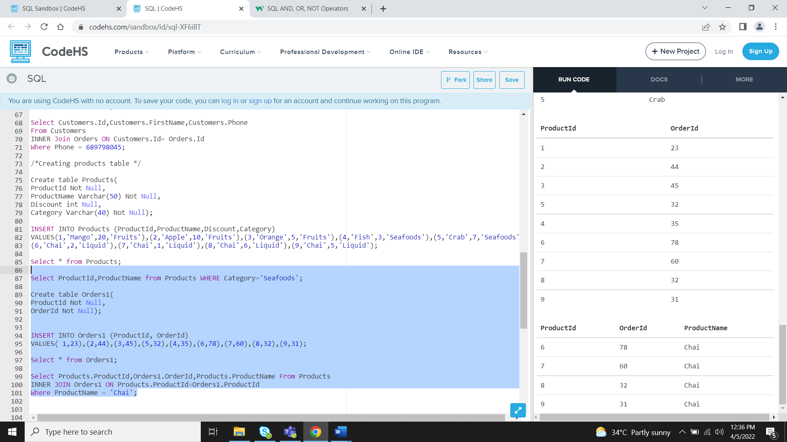

**/*Creating products table */**

Create table Products(

ProductId Not Null,

ProductName Varchar(50) Not Null,

Discount int Null,

Category Varchar(40) Not Null);

INSERT INTO Products (ProductId,ProductName,Discount,Category)

VALUES(1,'Mango',20,'Fruits'),(2,'Apple',10,'Fruits'),(3,'Orange',5,'Fruits'),(4,'Fish',3,'Seafoods'),(5,'Crab',7,'Seafoods'),

(6,'Chai',2,'Liquid'),(7,'Chai',1,'Liquid'),(8,'Chai',6,'Liquid'),(9,'Chai',5,'Liquid');

Select * from Products;

Select ProductId,ProductName from Products WHERE Category='Seafoods';

Create table Orders1(

ProductId Not Null,

OrderId Not Null);

INSERT INTO Orders1 (ProductId, OrderId)

VALUES( 1,23),(2,44),(3,45),(5,32),(4,35),(6,78),(7,60),(8,32),(9,31);

Select * from Orders1;

Select Products.ProductId,Orders1.OrderId,Products.ProductName From Products

INNER JOIN Orders1 ON Products.ProductId=Orders1.ProductId

Where ProductName = 'Chai';

**5.Write a query to display the name , department name and rating of any given employee**

***Create an Employee Table***

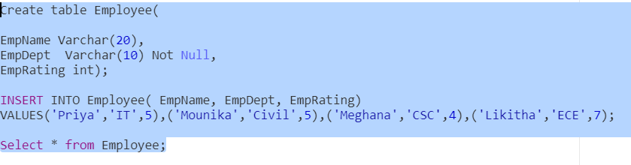

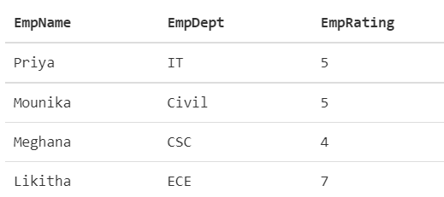

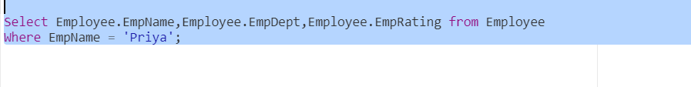

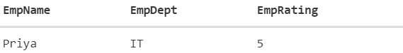

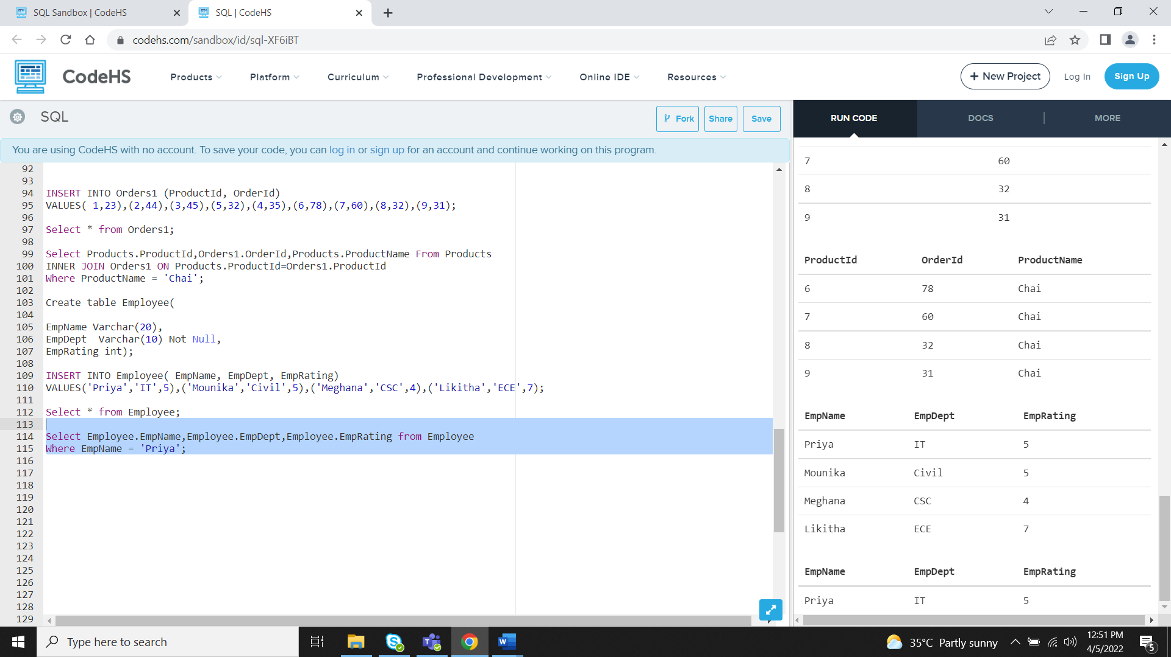

SQL Assignment -4 – Siva Priya Palakurthi

1.if the price is > 50 and also print it by Shipping company's Name Print the Total price of orders which have the products supplied by 'Exotic Liquids'

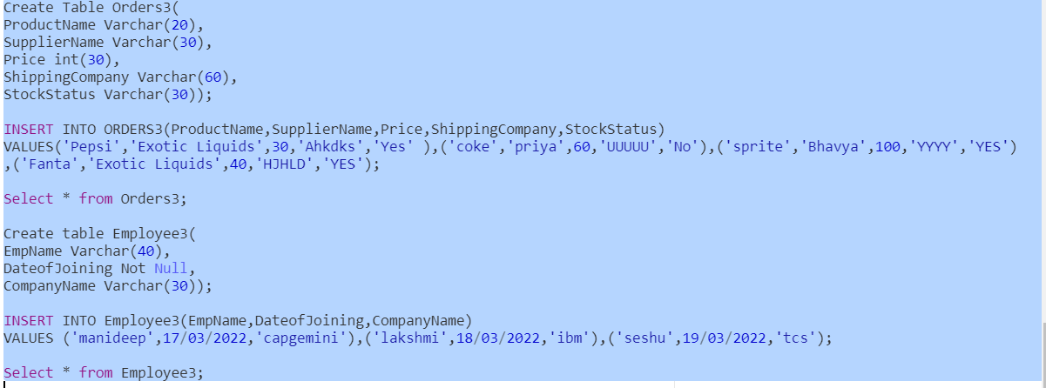

***SELECT SUM(Price) As Total,ShippingCompany***

***FROM Orders3***

***GROUP BY ShippingCompany***

***having SupplierName ='Exotic Liquids' and Price >50;***

***2.*** Display the employee details whose joined at first

***SELECT * FROM Employee3***

***group by DateofJoining***

***having count(*)=1;***

***3.*** Display the employee details whose joined at recently

***SELECT * FROM Employee3***

***group by DateofJoining***

***HAVING MAX(DateofJoining);***

***4.*** Write a query to get most expense and least expensive Product list (name and unit price).

***SELECT Price***

***FROM Orders3***

***ORDER BY Price asc;***

***SELECT Price, ProductName***

***FROM Orders3***

***WHERE Price =***

***(SELECT MIN(Price) FROM Orders3);***

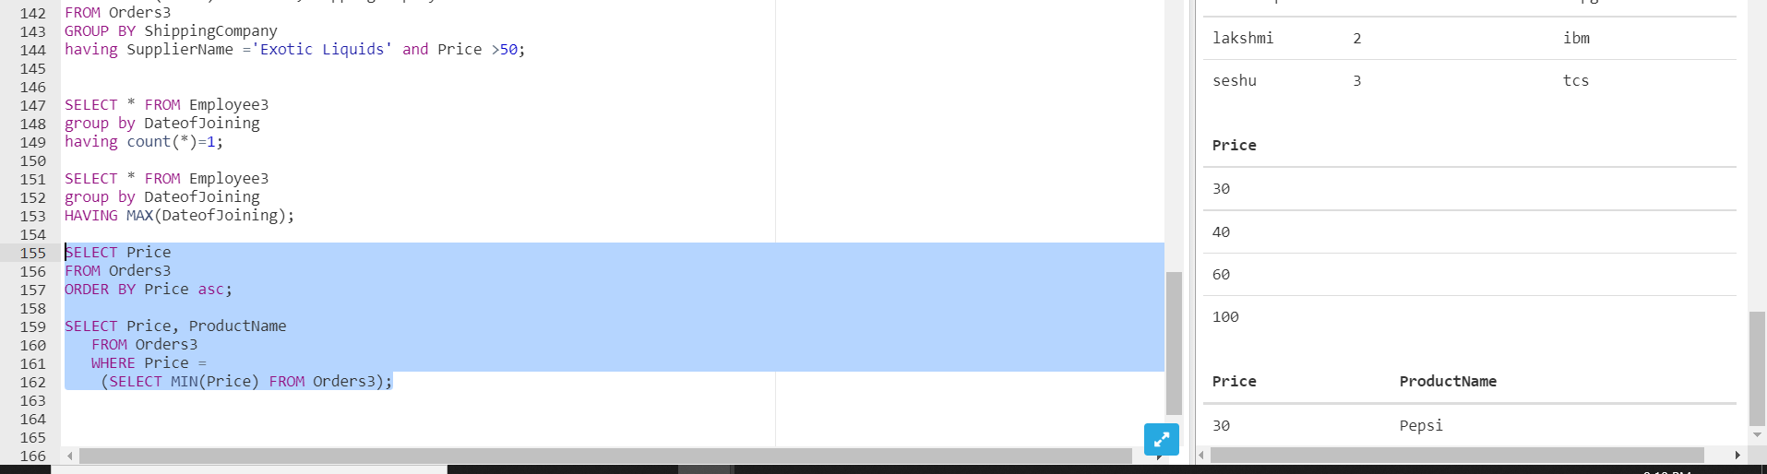

***5.*** Display the list of products that are out of stock

Select * from Orders3

Where StockStatus ='yes';

6. Display the list of products whose unitinstock is less than unitonorder

Select * from Orders3

Where InStock < UnitsOrder;

7. Display list of categories and suppliers who supply products within those categories

SELECT Categories,Suppliers

FROM Orders3

GROUP BY Categories,Suppliers

HAVING count(Categories)>=1 ;

8. Write query that determines the customer who has placed the maximum number of orders

SELECT * FROM Customer

where CustomerId=

(SELECT CustomerId FROM OrderTable

GROUP BY CUSTOMERID

HAVING MAX(CUSTOMERID)>0) ;